DCES Resources for English Learners (ELs)

PWCS Translation help: | (additional languages please call 703-791-7568)
(Arabic): 703-491-8432 Español (Spanish): 703-491-8432
한국어 (Korean): 703-791-8394 (Urdu): 703-791-7326 Tiếng Việt (Vietnamese): 703-791-7202
4956
Language Learning: Practicing Reading, Writing, Listening and Speaking daily is important!
Learning Apps | Read | Listen | Write
Duolingo - https://www.duolingo.com/ Free language learning app.  Starfall.com  https://www.starfall.com/h/  BrainpopELL  https://ell.brainpop.com/ | MyOn  https://www.myon.com/index.html  Newsela https://newsela.com/  Raz-Kids  https://www.learninga-z.com/ | CBC Kids News https://www.youtube.com/chan nel/UCWUA2W6LueNy9BSovi vFVvQ  Audible  https://stories.audible.com/start-listen  Storyline Online https://www.storylineonline.net/ | Typing Club https://www.typingclub.com/  Drawing App:  https://apps.apple.com/ca/app/kids-doodle-movie-kids-color/id460712294  (You can draw a picture, turn it into a movie and then write what you can making a story about it)  External Website – Clicking the link above exits the PWCS website.
Unite Books https://www.uniteforliteracy.com/  - free, no ads, no login, 40+ narration languages  External Website – Clicking the link above exits the PWCS website. | External Website – Clicking the link above exits the PWCS website. | TEDEd  https://ed.ted.com/  External Website – Clicking the link above exits the PWCS website.

Reference Materials: Tools to help you study, understand assignments, and stay organized.
English Dictionary  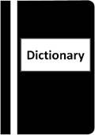 | Bilingual Dictionary  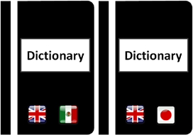  Flag icons: pixabay | Text to Speech & Speech to Text  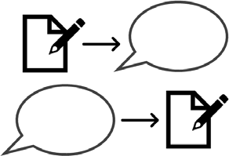 | Organize
Cambridge Dictionary https://dictionary.cambridge.org/u s/  External Website – Clicking the link above exits the PWCS website. | Word Reference - word to word translation https://www.wordreference.c om/  Bilingual Glossaries https://research.steinhardt.n yu.edu/metrocenter/resource s/glossaries  External Website – Clicking the link above exits the PWCS website. | Natural Reader - reads text aloud https://www.naturalreaders.co m/  Speech to text in Google YouTube video on how to use speech-to-text tools in Google Docs:  https://www.youtube.com/watch?v=_bVOZ_WpbCE  External Website – Clicking the link above exits the PWCS website. | Google Calendar  https://www.google.com/calendar/about/  Set daily/weekly goals and create a to-do list and create a study space and a schedule  External Website – Clicking the link above exits the PWCS website.
Wellness: Take care of yourself and your family. Stay healthy and reduce stress
- Take brain breaks and engage in physical activity - Go Noodle https://www.gonoodle.com/
- The National Child Traumatic Stress Network www.nctsn.org/resources/parent-caregiver-guide-to-helping-families-cope-with- the-coronavirus-disease-2019
- Healthy Children.org https://www.healthychildren.org/english/health-issues/conditions/chest-lungs/pages/2019-novel- coronavirus.aspx
- National Association of School Psychologists
https://www.nasponline.org/resources-and-publications/resources-and-podcasts/school-climate-safety-and-crisis/health-crisis- resources/talking-to-children-about-covid-19-(coronavirus)-a-parent-resource

External Website – Clicking the link above exits the PWCS website.

